Adult Education Careers Course Student Instruction

Log into www.virtualjobshadow.com (your login user name and password should be the same as in Odysseyware)

- If there is a blue “log in” button on the top right corner of the screen click on it.
- If you see this screen, with “Sutter County Superintendent of Schools” in the WHITE section you may login.

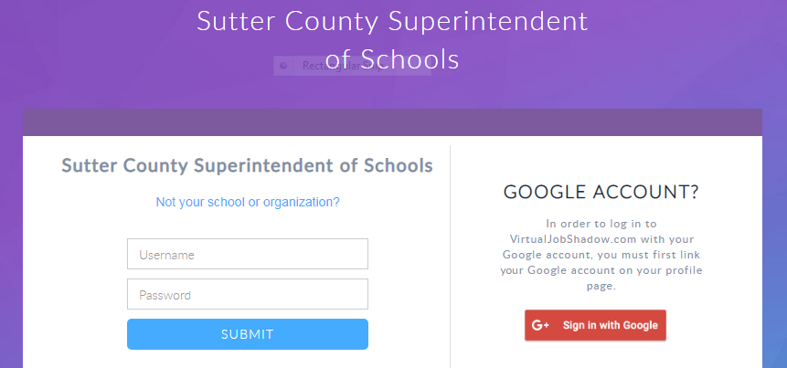

Username: first initial, last name, birth month, and day (jsmith1013). Password: your student ID number

If you see a screen with another school, you must CLICK ON “not your school or organization”, then type Sutter in the search box and SCROLL to and SELECT “Sutter County Superintendent of Schools”,
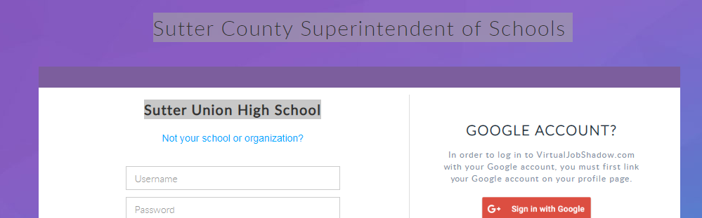

If you don’t see “Sutter County Superintendent of Schools” then type Sutter in the search box and SCROLL to and SELECT “Sutter County Superintendent of Schools”, Then proceed with your username and password.

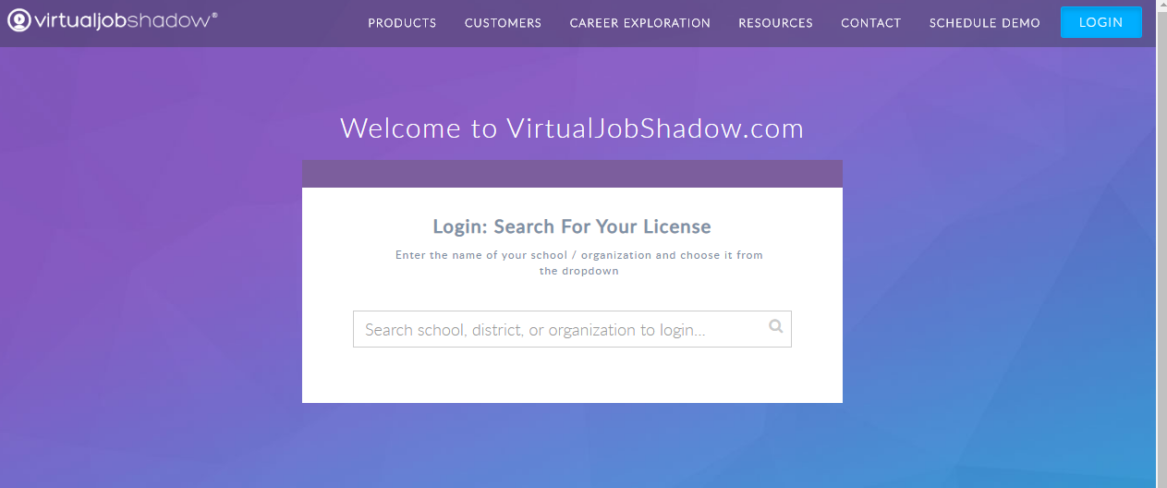

1. Complete (3) career assessments
- On the TOP of the screen, click on “Tools”, then click on “assessments”. Skip the first assessment (PINK BUTTON)
- Take the NEXT 3 assessments, Careers Cluster Interest Survey EZ (PURPLE “START NEW” button), O*NET Interest Profiler (GREEN “START NEW” button), and O*NET Work Importance Locator (BLUE “START NEW” button).
- YOU DO NOT NEED TO TAKE Careers Cluster Interest Survey (PINK BUTTON)
- After you complete each assessment, print the results page (Ctrl P)
  - To find the Assessment results, follow these steps:
  - On the TOP of the screen, click on “Tools”, then click on “assessments”.
  - Review results of assessments (click on blue “Results” box).
  - 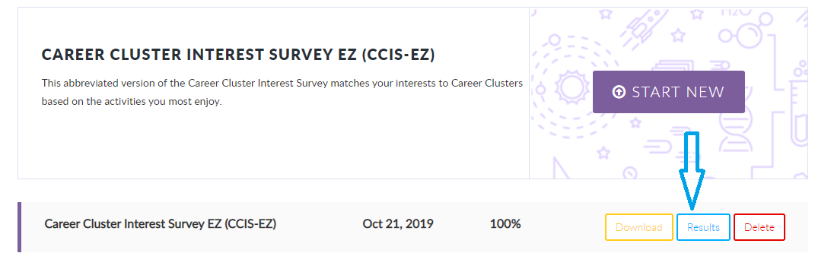
- Then, you will need to go back to the TOP of the screen and chose “Tools” and then click on “assessments” and take the next assessment and print the results page.
- Repeat until all three assessments are complete.

2. Career exploration of assessment results
From your career assessment results, choose one career, either the top rated or the most interesting to you from each of the three assessment results. For each career, watch all the videos, take the quiz, and complete a career journal entry. Follow the instructions below:
- On the TOP of the screen, click on “Tools”, then click on “assessments”.
- Review results of assessments (click on blue “Results” box).

- For EACH of the three assessments, click on ONE of your top industry results. 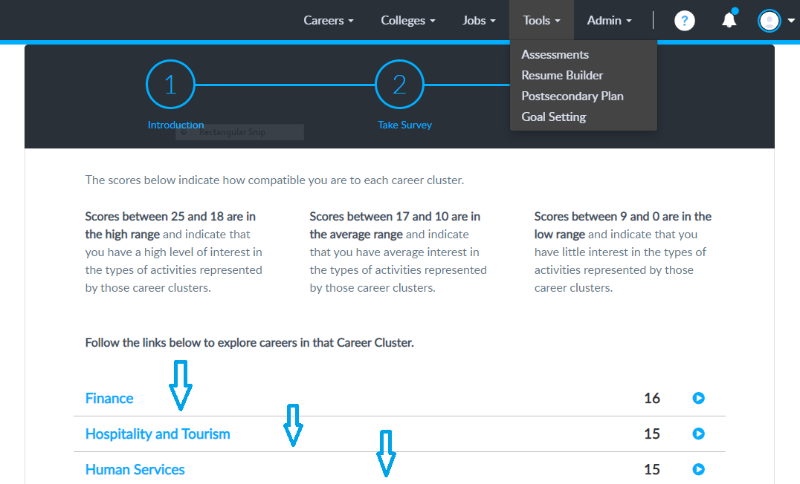

- From the industry result you just clicked on, select a career of interest.

- Watch videos and click on links on the left for important information that you will need to record in your career journal.
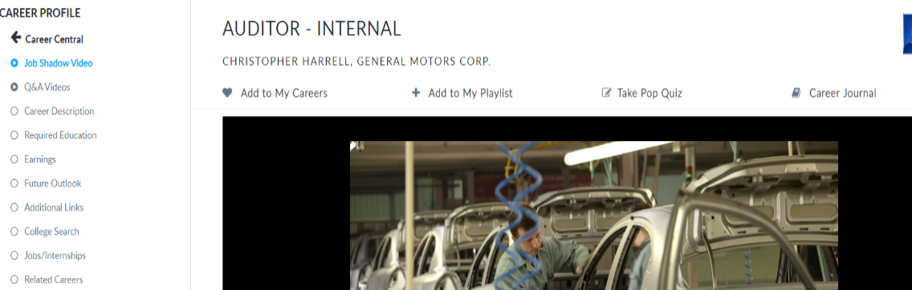

- Click on Career Journal
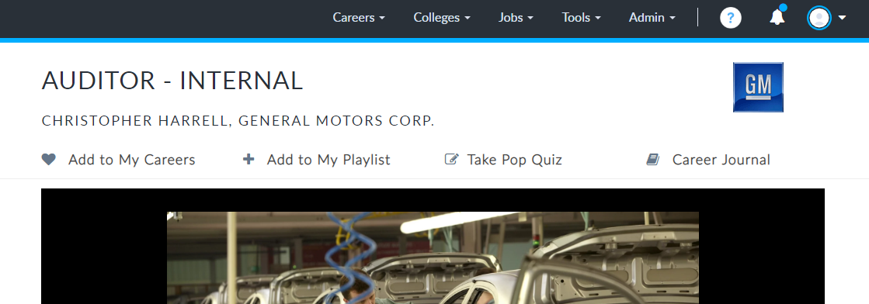

- Fill out all fields, click on save as often as needed.

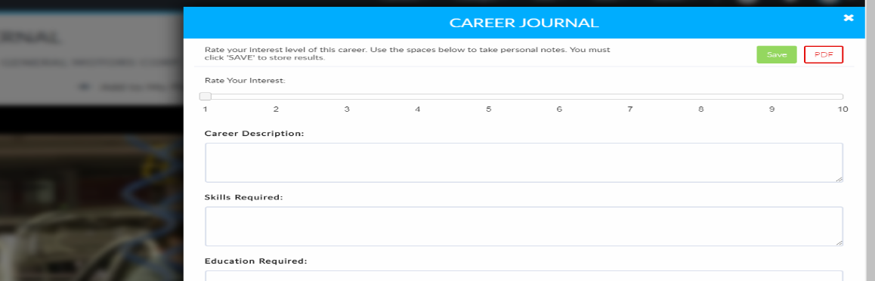

- Click on Take Pop Quiz.
Take quiz.
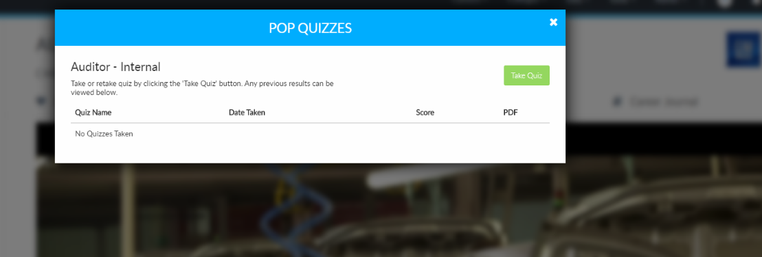
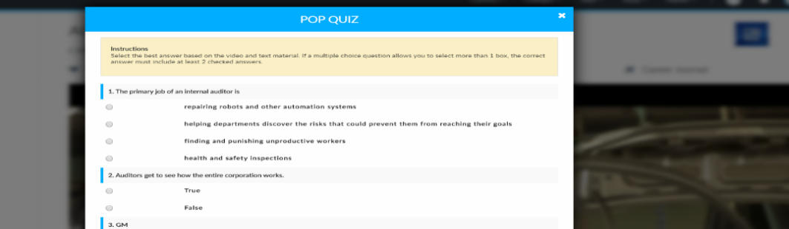

3. Research local/regional employers in top (2) careers
- Research available jobs that you would be interested in applying for now, or when you graduate, using Virtual Job Shadow (see directions following below).
- At the top of the screen, click on Jobs,
- and then Job Search.. Do at least 2 searches on job opportunities related to your top careers.
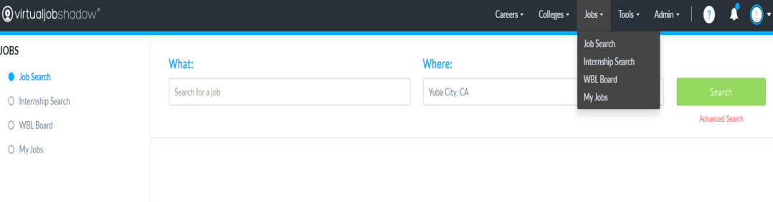
- You may need to change the search area to “Yuba County” or Northern California” if you do not get enough results from “Yuba City, CA” or if you are looking to relocate to another area.

- Email me a job description/job announcement for both career employment opportunities. You can copy and paste the link in the address bar of your browser and email it to me.

- 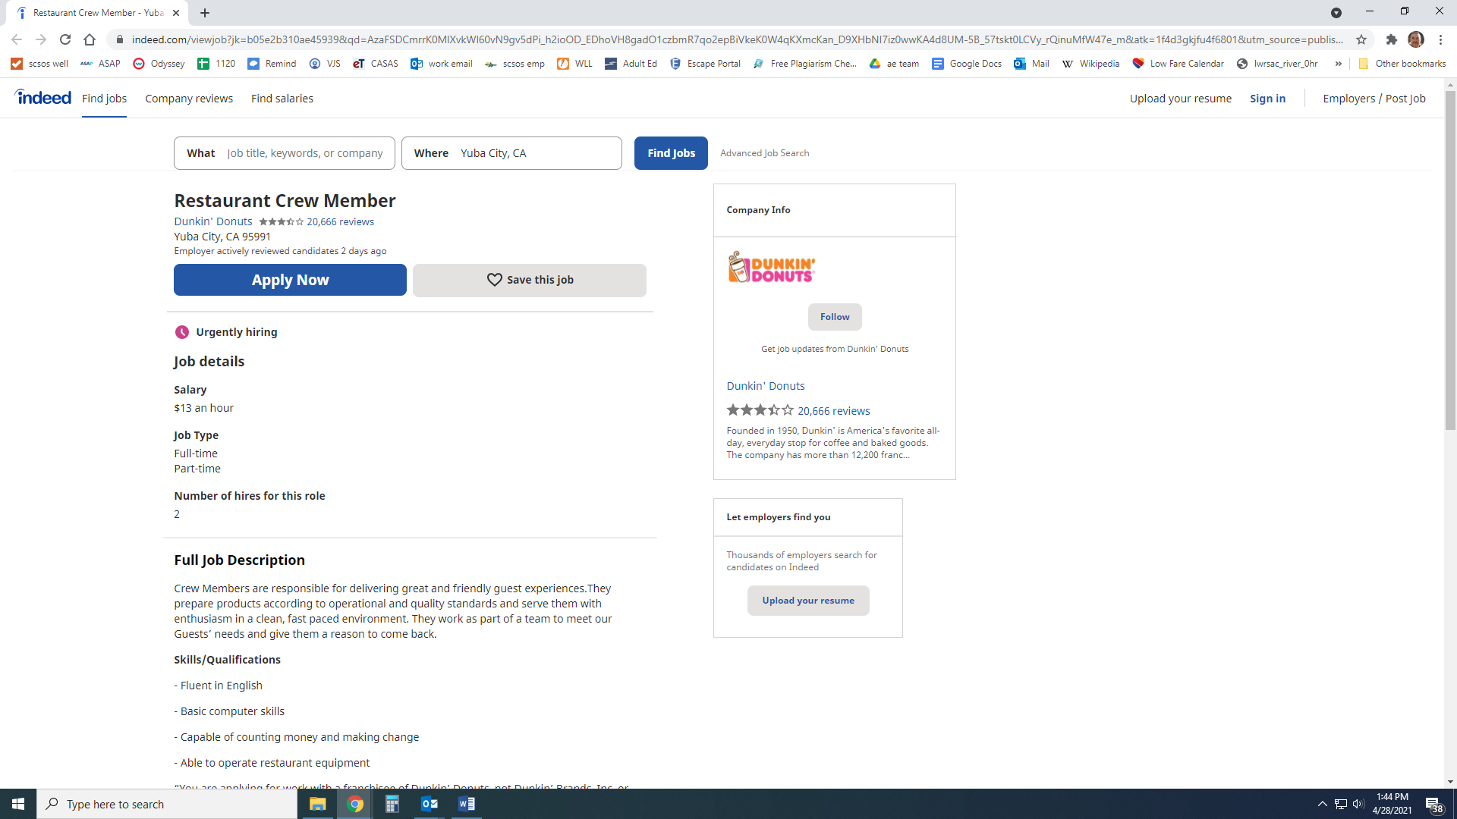

- Selecting certain jobs as “favorites” by clicking on the heart will save them to:
- “My Jobs” for future reference.

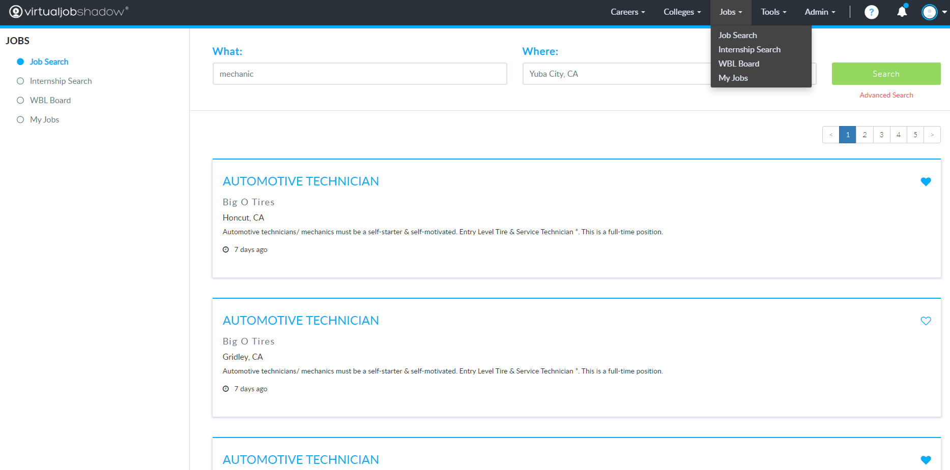

If you weren’t able to find two jobs that you are interested in applying for using Virtual Job Shadow, you can use other job search resources such as:
- Visit Job Central at Sutter County One Stop and check out the many job announcements that you might be interested in.
- View job leads in the Sutter County One Stop Job Lead Packet by going to www.sutteronestop.com and from the home page choose Looking For Job Opportunities and Hiring Events?.
- Register on Cal Jobs at www.caljobs.com and job search by county and job title.

- EMAIL LINKS TO JOBS YOU SELECTED TO pcannelora@sutter.k12.ca.us

